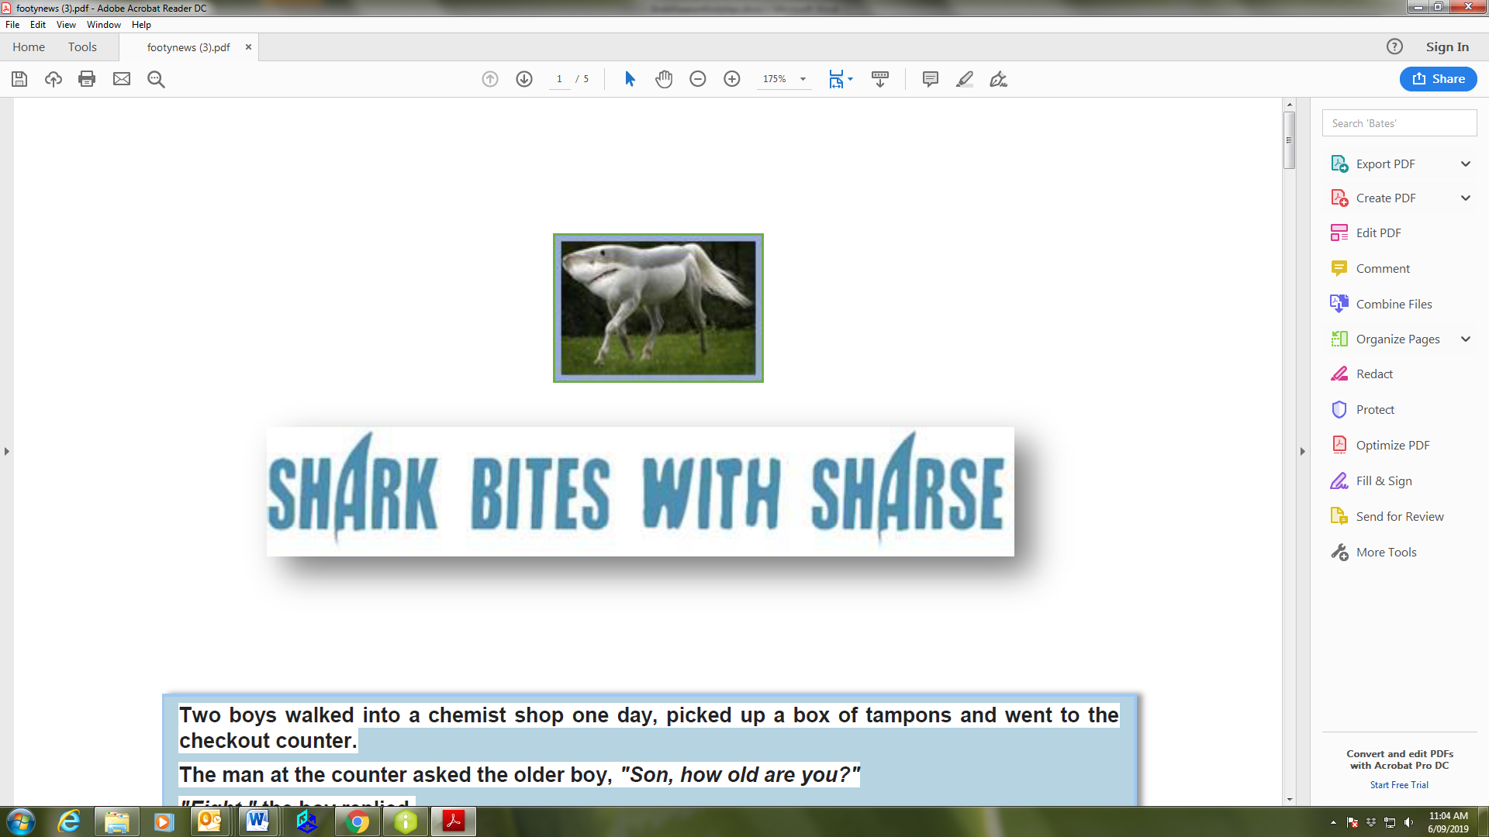

Infoware Footy Tipping for 2026 – late season chat
A belated welcome to our old and new tipsters for 2026.

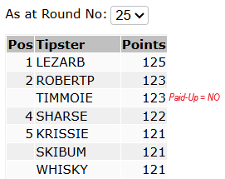



LEZARB has managed to get his nose in front by 2 points since round 23 with a couple of gutsy tips. With only 2 rounds left he’ll be hard to catch now, but not impossible! It’s been an exciting comp with no clear winner at any stage.
JACKPOTS
A reminder to our newbies that there is a $10 weekly jackpot up for grabs if you are the highest-scoring tipster on your own (you do NOT have to get them all correct). The jackpot win is denoted by an ‘*’ next to your points.
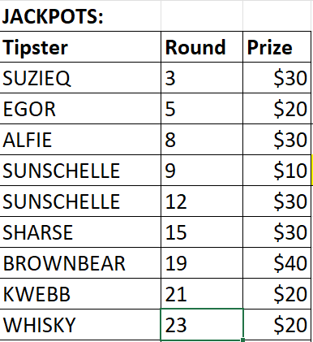
SUZIEQ first off the rank the year with a jackpot - entry fee already recovered and $10 left over for SUZIEQ’s next red wine.


and well done SUNSHELLE with 2 in a row

************************************************************************************************
A word or three from Sharse
Apologies. This is welcome, mid-season update and almost “the winners are” compressed all into the 1 chat.
The mid-season update would have focused on NSW getting 1 up on QLD in the first state of origin where NSW were up 14 players to Qld’s 12 ~ with Ashley Klein winning the man of the match. Anyway, this news is ‘fish n chip’ paper now.
Next year’s State of Origin is more interesting. Unusually both states with new coaches next year with Billy Slater announcing his departure in prep for a bigger role at the Storm.
Lots of possible candidates for QLD job but all to date have been quick to say ‘no’ as Billy Slater a very hard act to follow. Now newspaper talk of Wayne Bennet being brought out of SOO retirement to state duties (please no…).
Even though wearing a Blues NSW coaching jumper, I have a soft spot for fellow “Casinoite” Matt King. His forefathers were responsible for one of my many addictions growing up ~ pie and peas. Far beyond being Casino’s best pies they were simply the best pies ~ full stop. Far superior to the famed Harry's Café de Wheels in Woolloomooloo in Sydney. So as I do not end up in a defamation case, this is based on my experience and failing memories of the early 1980’s.
Now I am no longer growing up but growing out, the pie and peas addiction still continues today. Hopefully Matt King remembers his roots and fills up the NSW team with pies and peas before each SOO game to give the maroons a chance.
There are lies, damn lies and ( Infoware footy tipping ) statistics. ‘Sharse’ has never finished in the top 20 in 30 odd years of tipping. I am ticking off my bucket list of being on top of comp in rounds 20 & 21. While it is not winning the comp, it is probably the closest I will ever get and certainly the best by a long way I have been in tipping. The astute TIMMOIE, was on top in these rounds however this year decided to go on a ‘fun run’ of
‘playing without paying’, so like all statistics you keep redefining until you get the numbers you want (top of the paying players in rounds 20 & 21).

***********************************************************************************
Sharks
It is down to the pointy end of the season. They have gone from too slow for the 2026 ‘fastest yet’ game of bazball to 3 weeks ago of ‘what is bazball? and the Sharks moving from the quiet achievers to the ‘rumble on the horizon’ being on the 4th rung on the ladder. The last 3 rounds the tyres are punctured. Although in the words of the prophet Craig Fitzsommons the second half against the Titans they have found their mojo, blocking out the opposition with very low error rate, held the opposition scoreless and scored 4 tries.
Now they are in 5th position. The experts say you can only win GF if in top 4 according to history. My limited understanding is we live life every day - that in hindsight is called ‘history’. It is a knockout from round 2 of semis regardless of whether they finish 4th or 5th. This round 26 game Roosters vs Dolphins if Roosters win may push the mighty sharks back to 4th (if we can beat Whatsthematter and Storm).
All the top 4 sides have also had punctured tyres in at least 1 of the last 3 rounds so the premier position in both NRL and Infoware Footy Tipping is still up for grabs.
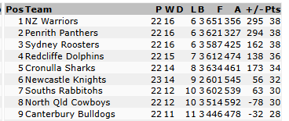

The sharks became the first team in 2025 off season to not sign on any significant new players - zilch. Commitment to the same team that got knocked out in prelim final the last 2 years. Whether this is a stroke of genius or not, early October will tell.

Next year a different story with many departures due to salary cap and some well performing players who can be paid more elsewhere (or retire on their riches).

League Philosophy
I will leave you to ponder a couple of league philosophical questions:
- What is a knock on?
About 80%+ dropped balls are called knock ons ~ when clearly the ball went backwards
- What is 6 again?
Lack of clarity for minor breaches – what are these?
While concussion is an important concern, head high dangerous tackles has now migrated to ‘tickling the ear when opponent is on the ground’ is a penalty!
Sharse signing off

Key On-Field Rule Changes
Trainer rules –
Trainers will be restricted from entering the field of play to prescribed and clearly defined circumstances. This will ensure player safety remains the priority while reducing unnecessary intrusions by Trainers carrying messages.
Interchange rules –
Teams may interchange four players, up to eight times per match, from a squad of six players (players 14 to 19 inclusive).
Accidental breach (“zero tackle”) in-goal – There will be no seven-tackle set following a knock-on in-goal by the attacking team.
Restarting the tackle count –
For certain infringements beyond the 20-metre line, the tackle count will restart, replacing the current 40-metre threshold.
The ARLC has also endorsed a trial of a proposed rule regarding the non-scoring team having the option of kicking-off or receiving from the restart. The change will be trialled in games with no bearing on the finals at the back end of the 2026 season before further consideration.


FUNNIES
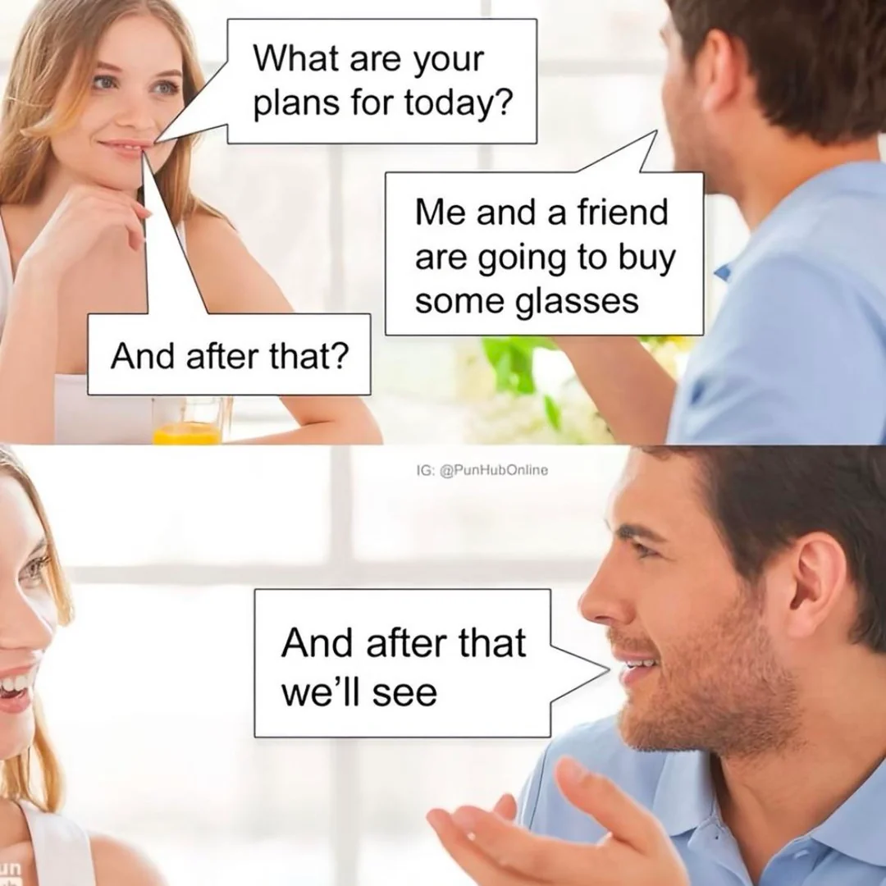
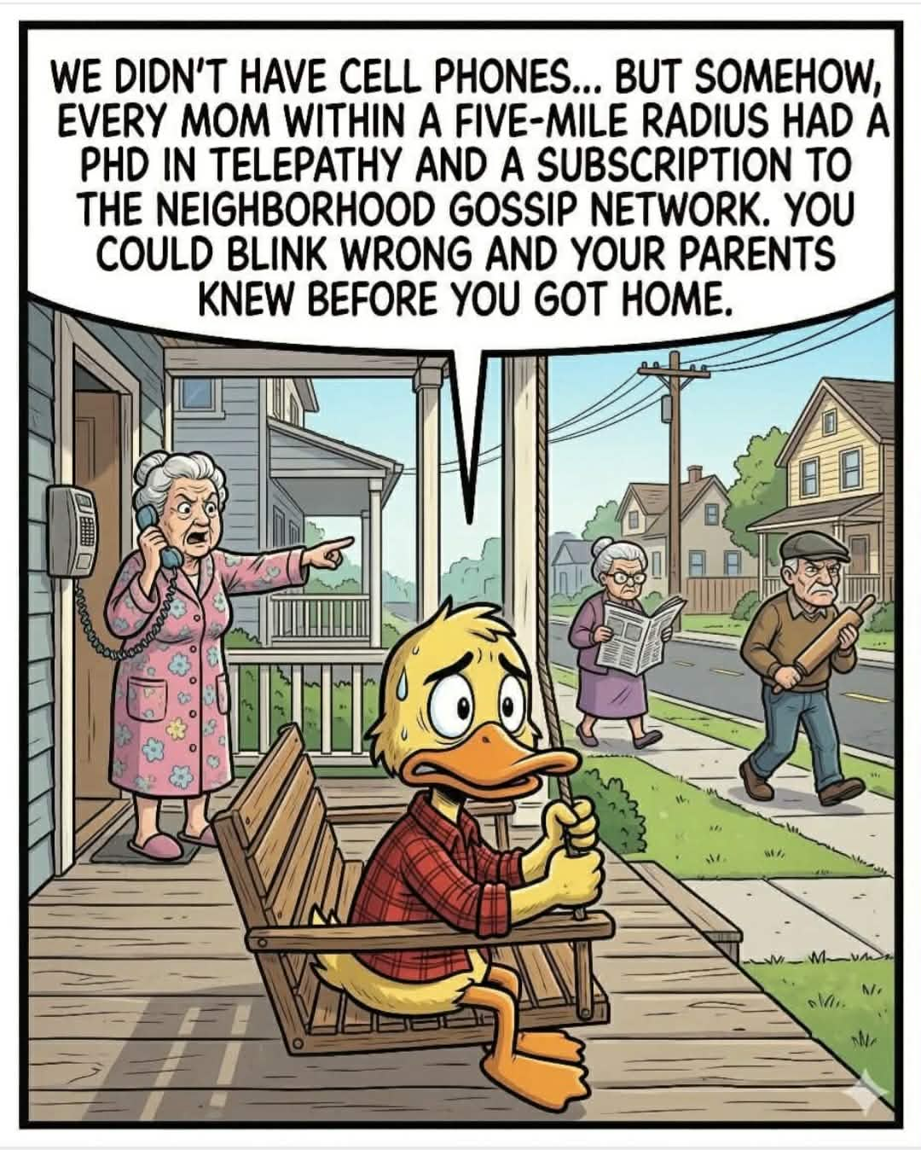

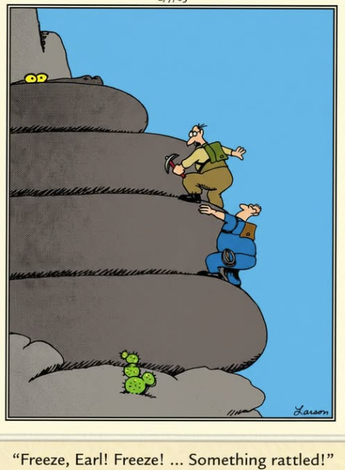

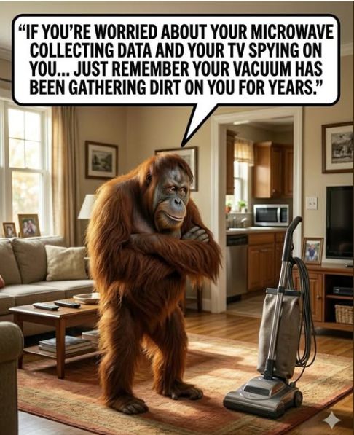

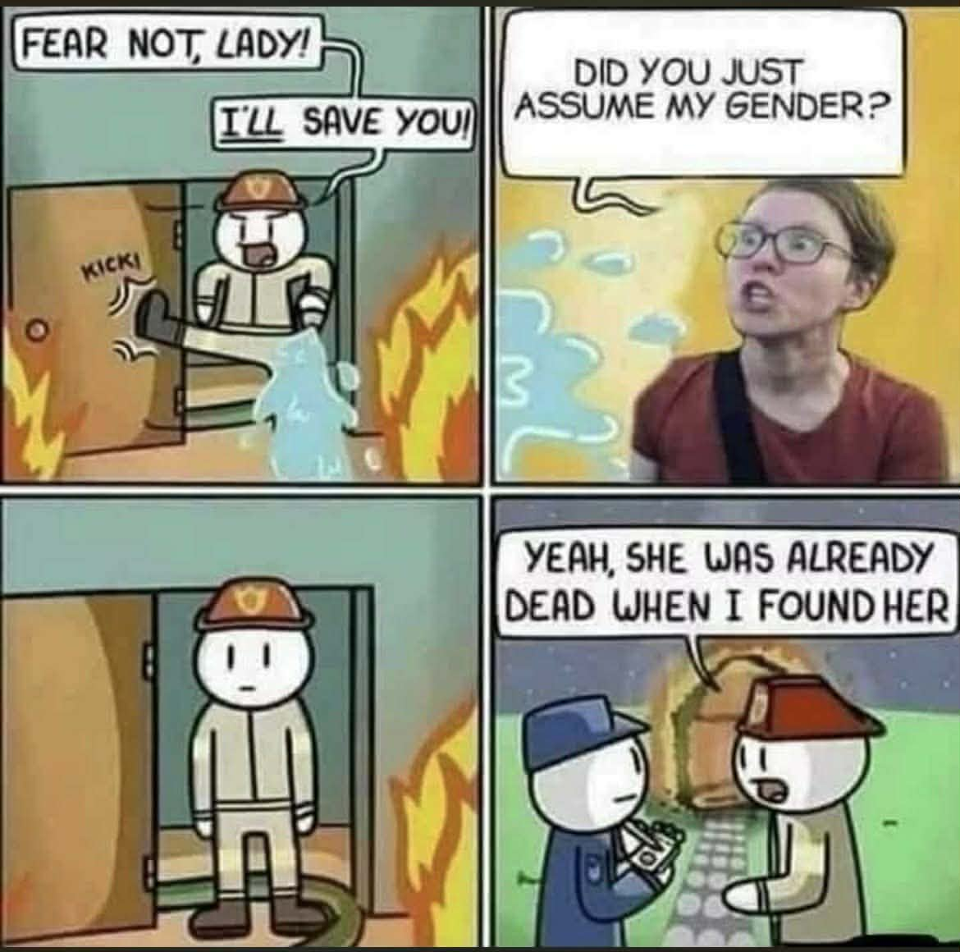



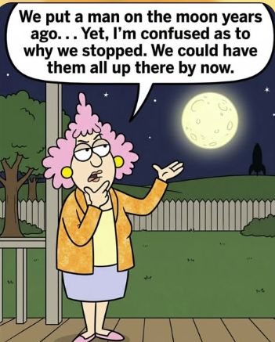



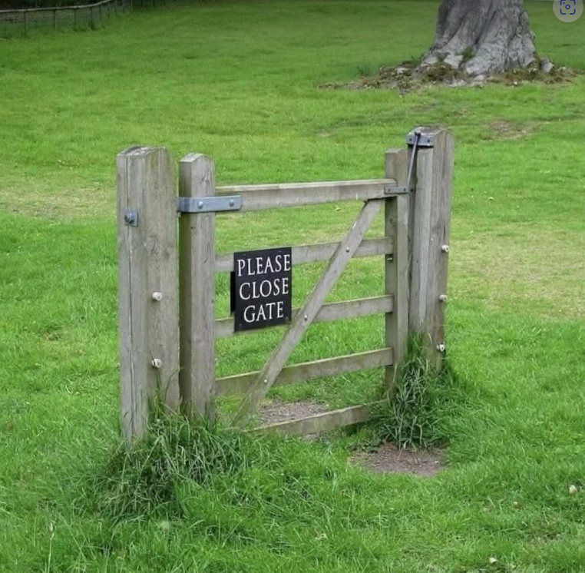





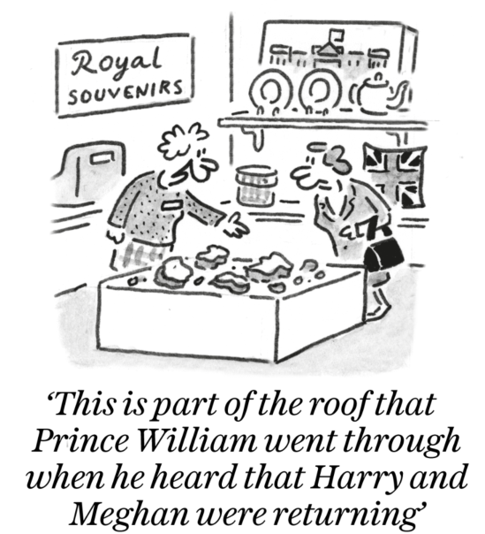

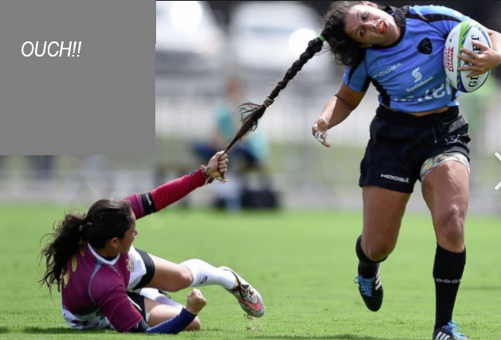



And last but not least…
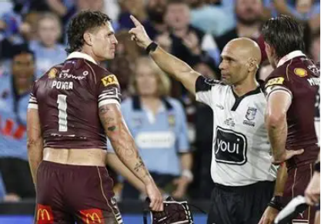

Best of tipping luck and health to everyone
Until next time

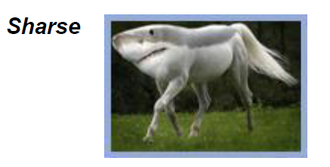
Whisky
